What is Acne?
Acne is the term for plugged pores (blackheads and whiteheads), pimples, and even deeper lumps (cysts or nodules) that occur on the face, neck, chest, back, shoulders and even the upper arms. Acne affects most teenagers to some extent. However, the disease is not restricted to any age group; adults in their 20s - even into their 40s - can get acne. While not a life threatening condition, acne can be upsetting and disfiguring. When severe, acne can lead to serious and permanent scarring. Even less severe cases can lead to scarring.
Types of Acne
When you read about acne or other skin diseases, you encounter words or phrases that may be confusing. For example, the words used to describe the lesions of acne—comedo, papule, pustule, nodule and cyst—are understandable only if you know each word’s definition. It also is helpful to have a photo that is characteristic for each type of lesion.
Here is a brief summary of definitions of words used to describe acne, with accompanying photos. Let’s begin, though, with the definition of lesion, an
all-purpose word:
Lesion—a physical change in body tissue caused by disease or injury. A lesion may be external (e.g., acne, skin cancer, psoriatic plaque, knife cut), or internal (e.g., lung cancer, atherosclerosis in a blood vessel, cirrhosis of the liver).
Thus, when you read about acne lesions you understand what is meant—a physical change in the skin caused by a disease process in the sebaceous follicle.
Acne lesions range in severity from comedones (blackheads and whiteheads) to nodules and cysts. Here is a brief definition of acne lesions:
Comedo (plural comedones)—A comedo is a sebaceous follicle plugged with sebum, dead cells from inside the sebaceous follicle, tiny hairs, and sometimes bacteria. When a comedo is open, it is commonly called a blackhead because the surface of the plug in the follicle has a blackish appearance. A closed comedo is commonly called a whitehead; its appearance is that of a skin-colored or slightly inflamed "bump" in the skin. The whitehead differs in color from the blackhead because the opening of the plugged sebaceous follicle to the skin’s surface is closed or very narrow, in contrast to the distended follicular opening of the blackhead. Neither blackheads nor whiteheads should be squeezed or picked open, unless extracted by a dermatologist under sterile conditions. Tissue injured by squeezing or picking can become infected by staphylococci, streptococci and other skin bacteria. The following photos are characteristic of acne with comedones:
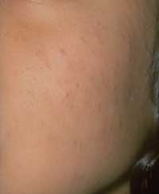 | 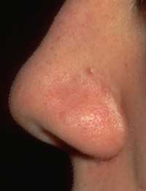
(Photos used with permission of the American Academy of Dermatology National Library of
Dermatologic Teaching Slides and the Sulzberger Institute for Dermatologic Education)
Papule—A papule is defined as a small (5 millimeters or less), solid lesion slightly elevated above the surface of the skin. A group of very small papules and microcomedones may be almost invisible but have a "sandpaper" feel to the touch. A papule is caused by localized cellular reaction to the process of acne. This photo shows papules and comedones on the face of an acne patient:
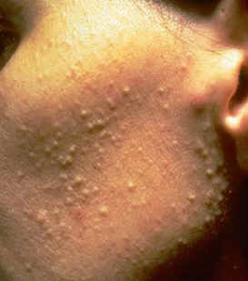
(Photos used with permission of the American Academy of Dermatology National Library of Dermatologic Teaching Slides and the Sulzberger Institute for Dermatologic Education)
Pustule—A dome-shaped, fragile lesion containing pus that typically consists of a mixture of white blood cells, dead skin cells, and bacteria. A pustule that forms over a sebaceous follicle usually has a hair in the center. Acne pustules that heal without progressing to cystic form usually leave no scars. This photo shows pustules, papules and comedones on the face of an acne patient:
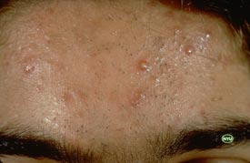
(Photos used with permission of the American Academy of Dermatology National Library of Dermatologic Teaching Slides and the Sulzberger Institute for Dermatologic Education)
Macule—A macule is the temporary red spot left by a healed acne lesion. It is flat, usually red or red-pink, with a well defined border. A macule may persist for days to weeks before disappearing. When a number of macules are present at one time they can contribute to the "inflamed face" appearance of acne. This photo shows the "red face" appearance of acne with macules:
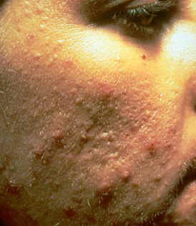
(Photos used with permission of the American Academy of Dermatology National Library of Dermatologic Teaching Slides and the Sulzberger Institute for Dermatologic Education)
Nodule—Like a papule, a nodule is a solid, dome-shaped or irregularly-shaped lesion. Unlike a papule, a nodule is characterized by inflammation, extends into deeper layers of the skin and may cause tissue destruction that results in scarring. A nodule may be very painful. Nodular acne is a severe form of acne that may not respond to therapies other than isotretinoin (Click on Acne Treatments)
Cyst—A cyst is a sac-like lesion containing liquid or semi-liquid material consisting of white blood cells, dead cells, and bacteria. It is larger than a pustule, may be severely inflamed, extends into deeper layers of the skin, may be very painful, and can result in scarring. Cysts and nodules often occur together in a severe form of acne called nodulocystic. Systemic therapy with isotretinoin is sometimes the only effective treatment for nodulocystic acne. Some acne investigators believe that true cysts rarely occur in acne, and that (1) the lesions called cysts are usually severely inflamed nodules, and (2) the term nodulocystic should be abandoned. Regardless of terminology, this is a severe form of acne that is often resistant to treatment and likely to leave scars after healing. These photos show nodular, cystic acne:
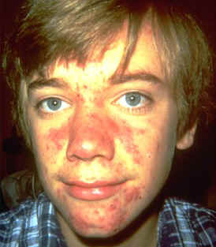
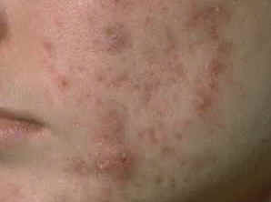
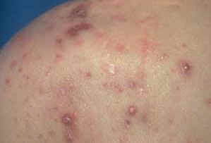
(Photos used with permission of the American Academy of Dermatology National Library of Dermatologic Teaching Slides and the Sulzberger Institute for Dermatologic Education)
Who gets acne?
Close to 100% of people between the ages of twelve and seventeen have at least an occasional whitehead, blackhead or pimple, regardless of race or ethnicity. Many of these young people are able to manage their acne with over-the-counter (nonprescription) treatments. For some, however, acne is more serious. In fact, by their mid-teens, more than 40% of adolescents have acne severe enough to require some treatment by a physician.
In most cases, acne starts between the ages of ten and thirteen and usually lasts for five to ten years. It normally goes away on its own sometime in the early twenties. However, acne can persist into the late twenties or thirties or even beyond. Some people get acne for the first time as adults.
Acne affects young men and young women about equally, but there are differences. Young men are more likely than young women to have more severe, longer lasting forms of acne. Despite this fact, young men are less likely than young women to visit a dermatologist for their acne. In contrast, young women are more likely to have intermittent acne due to hormonal changes associated with their menstrual cycle and acne caused by cosmetics. These kinds of acne may afflict young women well into adulthood.
Acne lesions are most common on the face, but they can also occur on the neck, chest, back, shoulders, scalp, and upper arms and legs.
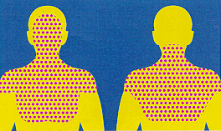
Normal distribution of acne
Acne also has significant economic impact. Americans spend well over a hundred million dollars a year for nonprescription acne treatments, not even taking into account special soaps and cleansers. But there are also the costs of prescription therapies, visits to physicians and time lost from school or work.

